JECRC
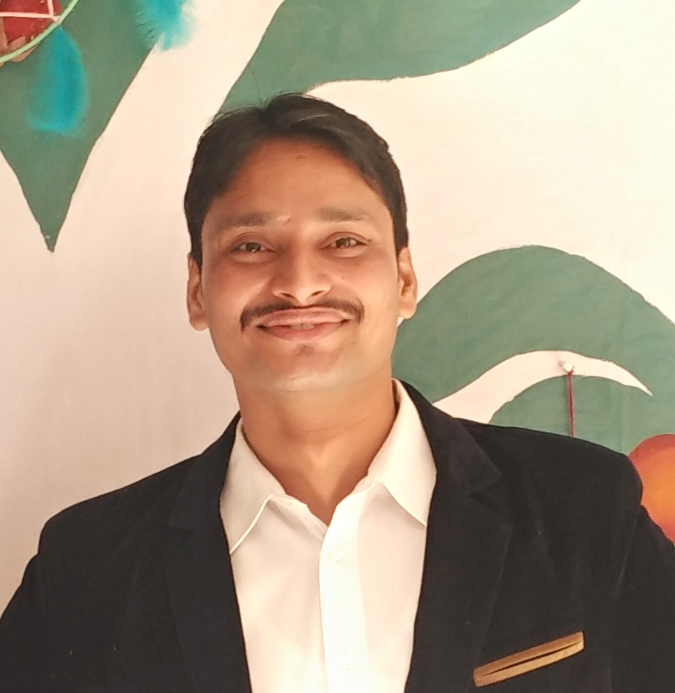
JAIPUR

INDIVIDUAL FACULTY DATA SHEET
Name of the faculty member | : | ASHOK SINGH CHUNDAWAT
Present Designation | : | Assistant Professor
Email Id : ashoksingh.ee@jecrc.ac.in
Contact Details :9887708601

I. Particulars of Educational Qualification: (only completed)

Category | Name of the Degree | Specialization | Year of Passing | Name of the College | Name of the University
UG | B.Tech | ELECTRONICS INSTRUENTATION AND CONTROL | 2012 | GOVT. ENGG. COLLEGE AJMER | RTU, KOTA
PG | M.Tech | INSTRUMENTATION AND CONTROL | 2015 | SLIET | SLIET
Ph.D.

II. Academic Experience : 3.4 Year

III. Industrial Experience :NIL

IV. Title of Ph.D. Thesis :NIL

V. Awards/Achievements : Coordinator in Smart India Hackathone 2017

VI. Research/Specialization : IMAGE PROCESSING

VII. Course Taught : CONTROL SYSTEM, ANALOG ELECTRONICS, UEP,EEE

VIII. Refereed International Journal Publication : 1

IX. International Conference Proceeding :2

X. Books Written : NIL

XI. M.Tech Thesis Guide : NIL

XII. PHD Thesis Guide :NIL

XIII. Professional Body Membership : NIL

